Five Parts of the Declaration of Independence
Jun 29, 2012 | General History
The Declaration of Independence is divided up into five parts:
- Introduction
- Preamble
- Body – Section 1
- Body – Section 2
- Conclusion
Introduction – In the introduction of the Declaration of Independence, declares the reasons the American colonies wish to leave the British Empire. It is further noted that their independence is not only necessary, but unavoidable.

Preamble – The preamble to the Declaration of Independence lists principles that were already known as being “self-evident” by the majority of Englishmen of the 18th Century. It continues to state that when such a situation arises in government (as that being experienced by the British governing of the 13 colonies), it is not only their desire, but it is their right and their duty to throw off such a Government and to provide the foundation for a new government to ensure their future security.

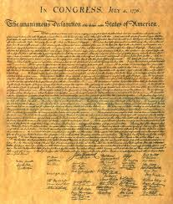Body – Section 1 – In this part of the Declaration of Independence, the grievances against England and King George III are listed.

Body – Section 2 – Section two of the body of the Declaration of Independence clearly states that the colonist’s efforts to appeal some of the decisions of King George III were met in vain.

Conclusion – The conclusion of the Declaration of Independence notes that having listed the grievances, under which British North American lived, they – the United Colonies – were declaring their right to be free and independent from any and all allegiance to the British Crown. It further stated that any political connection between the two is to be dissolved.

A great amount of courage and strength was exhibited by each member of the Continental Congress in adaptingand signing this historical document. The thought that went into writing and editing each of the five parts of the Declaration of Independence exhibited the pride of the newly established colonies and their desire to be free.

